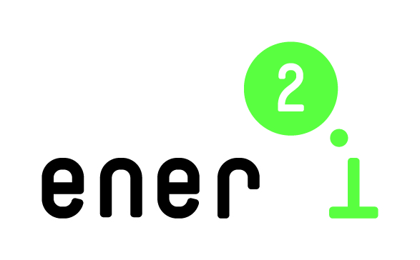 |  | 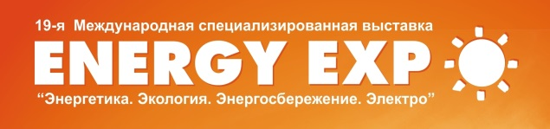

ener2i – energy research to innovation:
Reinforcing cooperation with Eastern Partnership countries on bridging the gap between energy research and energy innovation

ener2i Brokerage Event in Belarus
Announcement & Invitation

The EU funded project ener2i (www.ener2i.eu) invites to Brokerage Event on energy in Minsk, Belarus! The event will be held on October 14, 2014 in the framework of the XIX Belarusian Energy and Ecology Forum “ENERGY. ECOLOGY. ENERGY SAVING. ELECTRO” – ENERGY EXPO–2014.
The ener2i brokerage and the Energy Expo take place in the Roofed Soccer Arena, 20/2 Pobediteley ave., Minsk. We invite research institutions, universities, companies and Small and Medium sized Enterprises (SMEs), as well as business support organizations and other interested stakeholders with innovation targets in Renewable Energy Sources or in energy efficiency from Belarus, the European Union, from Eastern Partnership (EaP) countries, and beyond to participate in the ener2i brokerage event.
The ENERGY EXPO is the largest and most popular annual event on energy in Belarus. The EXPO features a large company exhibition and a scientific congress with several conferences and workshops. In 2013, the ENERGY EXPO hosted over 360 exhibitors from 18 countries and 15,000+ visitors. This year, the ENERGY EXPO – 2014 will be held on October 14-17, 2014, http://www.tc.by/english/events/.
The aim of the ener2i Brokerage Event is to provide an opportunity for enhancing the cooperation between Belarusian research organizations and businesses, and for establishing direct contacts and partnerships between Belarusian and foreign academic and business representatives, especially those from the EU and EaP countries. Part of the agenda will therefore be dedicated to pre-arranged face2face meetings and networking. Face2face meetings serve to find potential partners, to present competences, to discuss new project ideas and initiate partnerships for bi-lateral cooperation, or for joint projects in the EU’s Horizon2020 Programme for Research and Innovation (2014-2020).
The ener2i Brokerage Event is organized by local ener2i partners, the Belarusian Institute of System Analysis and Information Support of Scientific and Technical Sphere, http://www.belisa.org.by and the Belarusian Innovation Fund, http://www.bif.ac.by. Administrative support is provided by the State Committee on Science and Technology of Belarus and the Department of Energy Efficiency of the State Committee for Standardization of the Republic of Belarus.
How does it work?
The event is free of charge however, registration is mandatory through filling in a registration form (partner profile) at the ener2i website www.ener2i.eu before September 30, 2014.
Please, be aware that the earlier registration gives the organizers more time to disseminate the partnering requests and increases the chances to find partners.
Visa support and hotel recommendation will be provided by local organizers. We recommend registering quickly to those participants who need a visa to visit Belarus. A visa invitation letter will be provided by the local organizers upon registration.
As soon as the registration is completed, the applicants’ profiles will be collected in a catalogue to be forwarded to the registered participants by October 3, 2014. They will be requested to indicate preferable participants for face2face meetings and send their feedback by October 10, 2014 at latest. The catalogue will be uploaded on the ener2i and local organizer’s web-sites. Based on feedback provided, the organizers will suggest individual meeting agendas for matched participants before the start of the event.
A limited number of travel-grants for EU companies’ representatives to cover travel, accommodation and visa costs are available for participating in the ener2i Brokerage Event and the ENERGY EXPO. Please indicate in your registration, if such support is needed. A decision will be taken by the ener2i consortium and grantees will be informed about the outcome in due course.
Besides the ener2i Brokerage Event, its participants may get additional benefits through
- Taking part in the ENERGY EXPO – 2014 as an exhibitor, see conditions at http://www.tc.by/english/events/ (EN) or http://tc.by/exhibitions/energyexpo2014/ (RU)
- Visiting the ENERGY EXPO – 2014
- Taking part in the XIX Belarusian Energy and Ecology Congress which will start the day after the exhibition opening, on October 15, 2014 in Viktoria Hotel, 59 Pobediteley ave., Minsk. The Congress will include a high-level plenary session and several thematic conferences and workshops. One of these events, Innovation Training Workshop in Energy Efficiency and Renewable Energy Sources will be organized by the ener2i consortium on October 15, 2014. The workshop aims at facilitating the knowledge transfer from academia to business and support the commercialization of research results. Find more details about this workshop on the ener2i website www.ener2i.eu.
Contacts:
Local organizer  Belarusian Institute of System Analysis and Information Support of Scientific and Technical Sphere  7 Pobediteley ave., 220004 Minsk, Belarus |  | Ener2i Coordinating team  Centre for Social Innovation (ZSI)  Linke Wienzeile 246  1150 Vienna, Austria
Evgeny Gurinov, tel/fax +375 17 2094326, Gurinov@belisa.org.by  Olga Meerovskaya, tel/fax +375 17 2033139  meerovskaya@fp7-nip.org.by |  | Manfred Spiesberger, spiesberger@zsi.at  Gorazd Weiss, weiss@zsi.at  Katharina Büsel, buesel@zsi.at
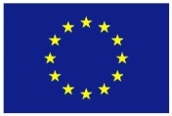 | This project has received funding from the European Union’s Seventh Framework Programme for research, technological development and demonstration under grant agreement no 609532.

